Sequence Diagram : 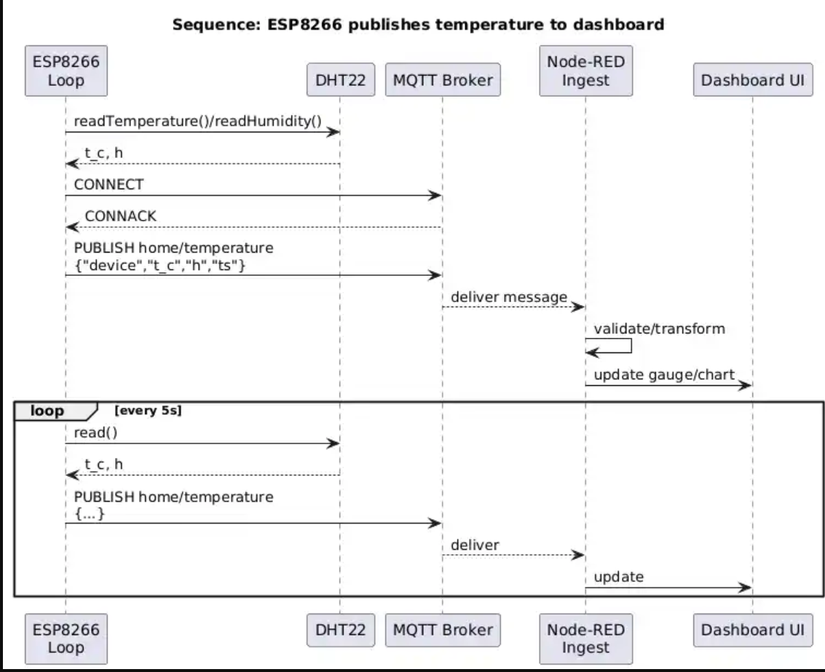

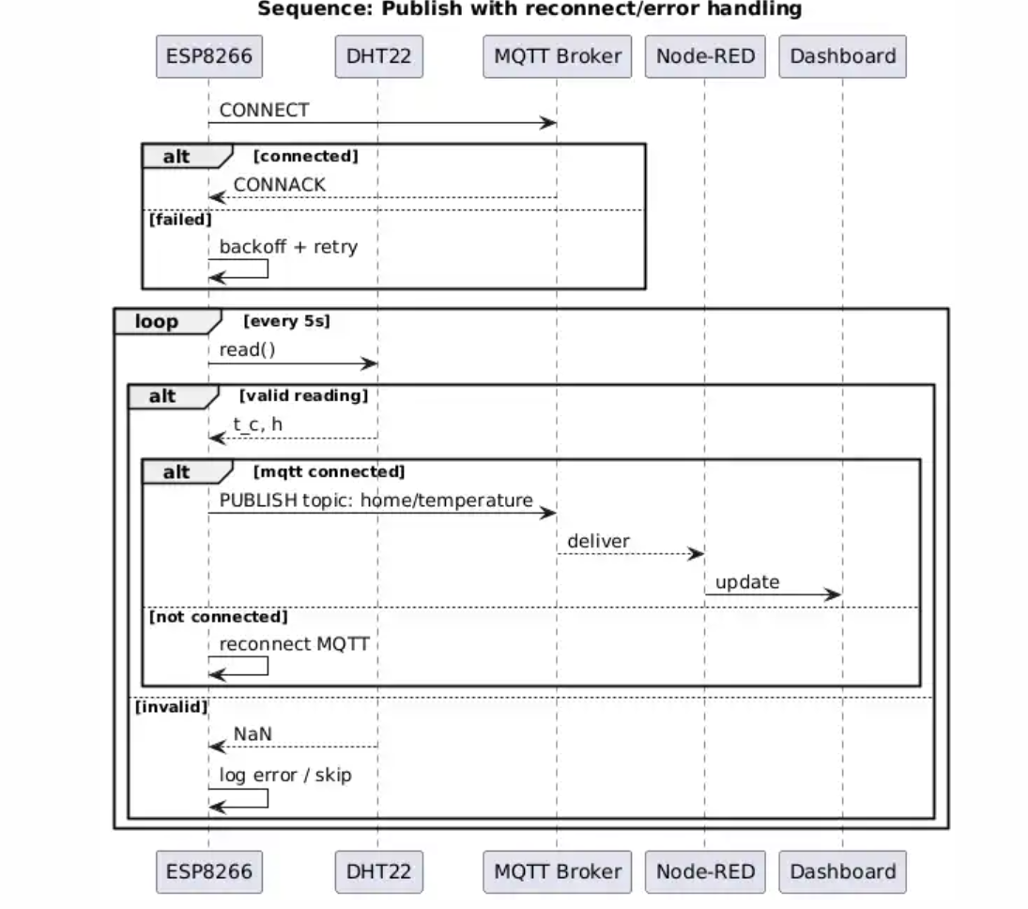
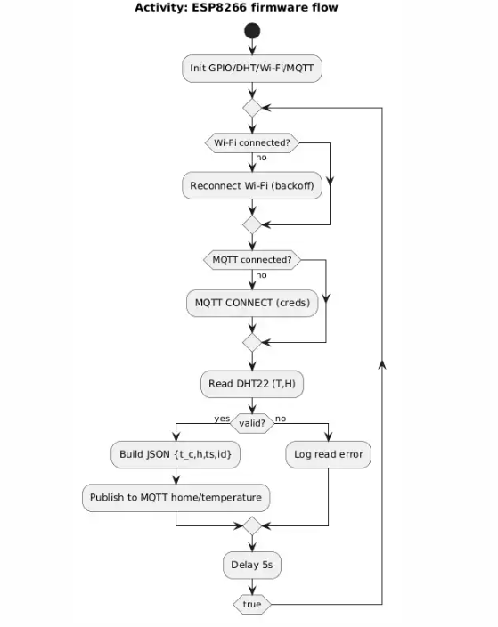

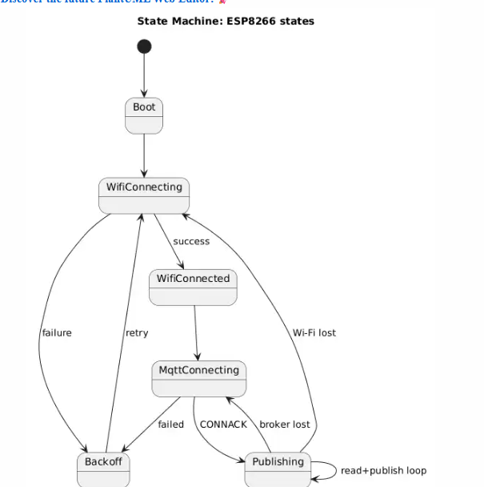
The sproject uses a modular edge-to-cloud architecture to deliver reliable temperature readings in my local network. The sensor node or the brain is an ESP8266 that reads a DHT22 sensor and publishes data via MQTT because MQTT is very lightweight , strong on Wi‑Fi, and widely supported by brokers and tooling. The firmware separates orders into a control loop, sensor I/O, and networking with reconnect/backups for redundancy. Payloads use small JSON with temperature, optional humidity, timestamp, and device id on a single subject (home/temperature), making it easier for routing and dividing. A Mosquitto broker separates the device from consumers. Node-RED subscribes to the topic, verify or confirms and transforms data if needed , has a real time dashboard (gauge/chart), and can add or subjoin optional storage later without changing the device. Security is initially scoped to a trusted LAN; the design cleanly supports credentials and TLS if exposed beyond the LAN. monitoring and detection is built-in, the device saves actions (connect, publish, sensor errors), and Node-RED provides quick look up and dashboards. The architecture helps other programming experiments (e.g., swapping MQTT with CoAP) by keeping everything tidy up.

